**Framework Explanation:**

**Definition:** Framework is collection of reusable components that makes automation development execution and modification is easier and faster.

**Framework has the following components:**

1. Generic Utilities
2. POM/Object Repository
3. Test Data
4. Test Scripts
5. XML file
6. HTML Report
7. Screen Shots
8. Reports
9. Common Data

**Below is the Framework Architecture:**

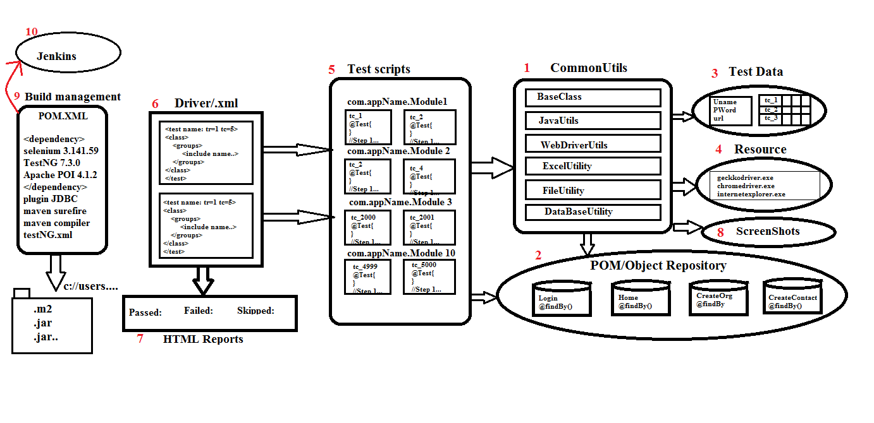

1. **Generic Utilities:** It is the common component in the framework which we can use in any other project also. It contains some generic methods which is the reusable code.

* **Base Class**: It consists of methods to perform some pre & post condition like connecting to database, launching the browser, login to application, logout from application, closing the browser, disconnecting the database.
* **Java Utility:** It contains java specific methods which can be used for all the test scripts like get-Random-number, get- System Date etc.
* **WebDriverUtility:** It contains web-drivers action which is common for all the test scripts like select class methods, action class methods, switch-To-Frame, TakesScreenshot etc., we use web driver utility to perform action on the browser so that the test script level is easy and no read to remember the syntax.
* **File Utility**: It is a class where we write methods to reading the data from the property file.
* **Listener class**: It is an implementation class for ITestListener interface which contains few abstract methods such as onStart(), onTestStart(), onTestFailure(),etc. These methods will be executed based upon the test scripts results.
* **Retry class**: It is an implementation class for IRetryAnalyzer interface which contains the retry() method which gets executed whenever the test script fails due to synchronization or network issues, the test script will re-execute again until it passes or the custom tries.
* **IPath Constants**: This is an interface where we will store file paths, Database URL & Database username & password.
* **Excel Utility**: In this we will write the methods to read data from excel & write data into excel.
* **Database Utility**: We will store common methods that are needed to connect to database, update or execute query from database & close the connection.

1. **POM pages/Object Repository**: POM stands for Page Object Model. For each web page we design a separate POM page where we will store the objects like locators of web elements & business libraries to handle StaleElementReferenceException.
2. **Test Data**: It contains the data which is required to run the framework, i.e. common data(Property file) & Test data(Excel file).
3. **Test scripts**: It contains the TestNG test scripts which is automated using @Test annotation. During test script development make sure generic libraries, object repository is being used.
4. **XML file**: It is a TestNG component which is used to execute the test scripts in batch, parallel, group, cross browser execution, etc.
5. **Reports**: Once the TestNG execution is completed it generates the HTML report which helps us to know the status of application. It is high level report. We can use the Extent Report also which is a customized report.
6. **Screenshots**: Whenever the test script is getting failed we can capture the screenshot in the screenshot folder to know in which page we are facing the issue.

**Advantages of Framework**:

1. Modules can be created & reused across different test cases which saves time & effort in writing repetitive code.
2. Data driven approach enables tests to use different input data without modifying the test logic, enhancing test coverage, etc.
3. Dividing tests into smaller modules & methods makes the overall test suite more readable & understandable.
4. Modification & maintenance of data is easy because data is stored in external resource.
5. With modular & method driven setup, it is simpler to run tests in parallel, optimizing test suite execution time.
6. Smaller units of code(methods) make it simple to identify & isolate issues for faster debugging.
7. POM design pattern is best suitable for Agile methodology.
8. If a module or method needs to be updated, it can be done without affecting the rest of the tests, minimizing downtime.